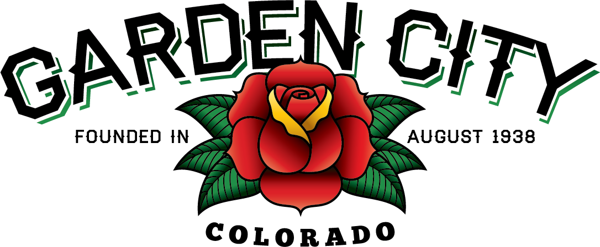

AGENDA
BOARD OF TRUSTEES
REGULAR MEETING 7:00 PM March 5, 2019

The Board will consider and may take action on the following items:
- Call To Order
- Roll Call
- Consent Agenda
  - Approve Minutes From February 19, 2019 Meeting
  - Approve Paid Bills
  - Approve Bills To Be Paid
  - Approve Journal Entries For 2018
- Public Not On The Agenda Invited To Be Heard
- Liquor Licensing Issues
  - El Rodeo Night Club LLC DBA El Rodeo Tavern With Live Entertainment Liquor License Renewal
- Marijuana Licensing Issues
  - LIVWELL I, LLC DBA LivWell Retail Marijuana Store License RMJ012019 Renewal Application
- Public Hearing Regarding USR 2019-01
- USR 2019-01
- Consider Wells Fargo Savings Account Closure
- Discussion Regarding Reflective Paint On Crosswalks
- Consider Weld County Referral SPR19-0002
- Approve Engagement Letter From ACM, LLP For 2018 Audit
- Consider Scrapped Bollard Heads Donation To Advanced Auto Pro’s
- Attorney’s Report
  - MEMO Gift Ban Increase 2019
- Police Chief’s Report
- Other Board Issues
- Announcements
  - ACM, LLP will be at Town Hall March 4 – 8, 2019 for the 2018 Audit
  - North Front Range Metropolitan Planning Organization Meeting, March 7, 2019 at Larimer County Offices Building, Carter Lake and Boyd Rooms, 200 W. Oak St., Fort Collins at 6:00 PM
- Adjourn

