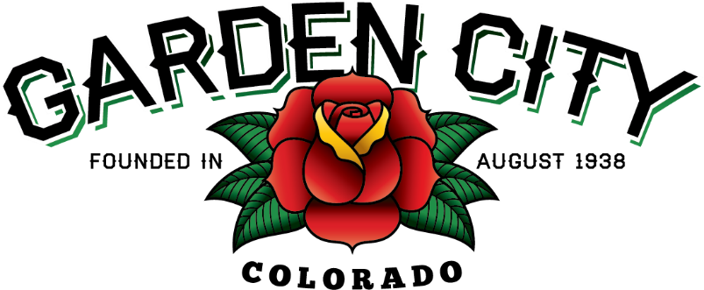

AGENDA
BOARD OF TRUSTEES
REGULAR MEETING 7:00 PM August 20, 2019

The Board will consider and may act on the following items:
- Call To Order
- Roll Call
- Consent Agenda
  - Approve Minutes From August 5, 2019 Meeting
  - Approve Treasurer’s Report For July 2019
  - Approve Paid Bills
  - Approve Bills To Be Paid
- Public Not On The Agenda Invited To Be Heard
- Grants
  - Consider Commercial Revitalization Grant Increase
  - Approve Commercial Revitalization Grant for 2717 7th Avenue
- Approve Municipal Law Annual Seminar At Cost Of $275 For Town Attorney Amy Penfold
- Consider 28th Street Issues
- Review Quotes And Award Project For Speed Bumps In Alley
- Update on Crosswalk Issues
- Consider Exterior Improvements To Town Hall
  - Consider Posting Online Only
  - Consider Stuccoing Exterior Of Town Hall
- Approve Estimate For The Wall Behind The PTSD Monument In The Amount Of $5,555.00
- Weld County Referral ZPAG19-0003
- Schedule December Meeting
- Attorney’s Report
- Police Chief’s Report
  - Approve Weld Count Task Force Contribution of $1,000.00
  - Incident Report
- Time Of Day Report
- Accident Report
- Citation Report
- Other Board Issues
- Announcements
  - Bootleggin’ Days August 23- 24, 2019. There is still time to volunteer.
  - CML District Meeting is on October 3, 2019 in Windsor from 4:00 – 7:30. Cost is $35 per person. RSVP by September 13, 2019.
- Adjourn

