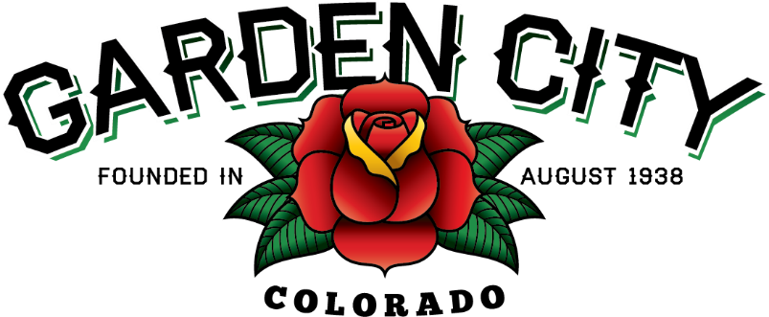

AGENDA
BOARD OF TRUSTEES
REGULAR MEETING 5:30 PM February 16, 2021

The Board will consider and may act on the following items:
- Call To Order
- Roll Call
- Consent Agenda
  - Approve Minutes From February 2, 2021 Meeting
  - Approve Minutes From February 9, 2021 Special Meeting
  - Approve Treasurer’s Report For January
  - Approve Paid Bills
  - Approve Bills To Be Paid
  - Approve Journal Entries For December, 2020 and January, 2021
  - Approve Turnkey Builders Invoice For Upgrades To Community Center In The Amount Of $11,159.08
  - Approve Tyler Invoice For 2020 Brazos Setup And Configuration In The Amount Of $11,000.00
  - Approve Tyler Invoice For General Ledger Production Assistance In The Amount Of $4,305.00
  - Approve Tyler Invoice For 2020 Brazos Rapid Extension Framework And eCitation Maintenance In The Amount Of $3,400.00
  - Approve Tyler Invoice For Financials Parallel Payroll In The Amount Of $3,045.00
- Public Not On The Agenda Invited To Be Heard
- AARP Presentation By James Riesberg
- Accept Resignation Of Town Attorney
- Approve Estimate From Surveyor In The Amount Of $3,500.00
- 2021 Streets Project
  - Approve Bid
  - Consider Concrete Sidewalks With Rollover Curb
- Consider Landscaping Proposals At US 34/8th Avenue Intersection
- Staff Reports
  - Town Administrator’s Report
  - Police Chief’s Report
- Other Board Issues
- Announcements
  - The CML Annual Conference June 22-25, 2021. Please RSVP to Abby or Bonnie, registration will be opening soon.
- Adjourn

