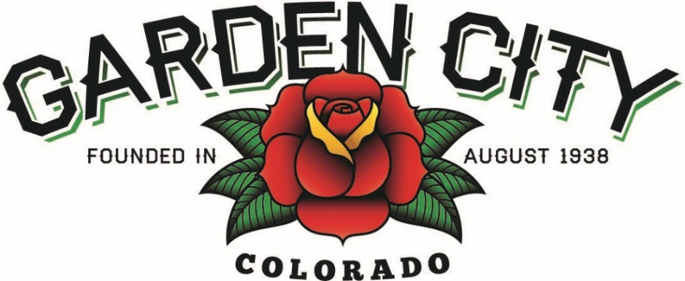

AGENDA
BOARD OF TRUSTEES
REGULAR MEETING 5:30PM October 18, 2022
The Board will consider and may act on the following items:
- Call To Order
- Roll Call
- Consent Agenda
- Approve Minutes from October 4, 2022 Regular Meeting
- Approve September 2022 Treasurer’s Report
- Approve Paid Bills
- Approve Bills To Be Paid
- Approve Water Rebate for Tammy Malick 2743 6th Ave Lane in the amount of $259.53
- Approve AirSolutions Heating and Air Conditioning invoice for the Shop in the amount of $7,442.50
- Approve 2Bros Construction invoice for the Community Center trim replacement in the amount of $2,500
- Approve Anderson & Whitney invoice in the amount of $10,000
- Public Not on the Agenda Invited to be heard
- Approve Report of Changes for El Baile LLC DBA El Bandido Night Club 618 25th Street Change of Registered Manager
- Grants
  - Approve Fence Grant for Carlos Vargas 2700 6th Ave Lane in the amount of $1,062.42
  - Approve Residential Revitalization Grant Carlos Vargas 2700 6th Ave Lane in the amount of $1,188.46
- Approve Eliseo Lopez as a signer on Stifel Investment Account
- Consider quotes for a new roof on the Community Center
- Schedule December 2022 Regular Meeting
- Approve Police Department Pay Schedules
  - Police Chief
  - Sergeant
  - Officer
- Staff Reports
  - Town Administrator
  - Police Chief
  - Public Works Director
  - Town Attorney
- Other Board Issues
- Announcements
  - North Range Behavioral Health will be at the Community Center on October 21, at 11AM for their Mental Health and Suicide Prevention seminar
  - Picasso and Wine is Saturday, October 22nd at 6PM
  - The Weld County Town and County Meeting is October 27h at 6PM
  - Clean up days is November 4-6
- Adjourn

